**Assignment**

**Name:** Bilal Haneef

**Roll #:** 44

**Teacher:** Miss Maleeha Anwar

**Topic:** Multiplexer and De- Multiplexer

**Section:** Sec A (Evening)

**Difference between Multiplexer and De- Multiplexer**

|  |  |
| --- | --- |
| **Multiplexer** | **De-Multiplexer** |
| **Multiplexer** is a combinational circuit that has maximum of 2n data inputs, ‘n’ selection lines and single output line. One of these data inputs will be connected to the output based on the values of selection lines. | **De-Multiplexer** is a combinational circuit that performs the reverse operation of Multiplexer. It has single input, ‘n’ selection lines and maximum of 2n outputs. The input will be connected to one of these outputs based on the values of selection lines. |
| **Multiplexer** takes two or a lot of signals and returns single output. | **De-multiplexer** reverses what the multiplexer does. |
| Communication system use **multiplexer** to carry multiple data like audio, video and other form of data using a single line for transmission. | The **demultiplexer** receive the output signals of the **multiplexer** and converts them back to the original form of the data at the receiving end. |
| A **multiplexer** is used in telephone  networks to integrate the multiple audio signals on a single line of transmission. | In an ALU circuit, the output of ALU can be stored in multiple registers or storage units with the help of **demultiplexer**. |

**Multiplexer of 8x1:**

Multiplexer of 8x1 has 8 input lines and 1 output lines,

Select lines will be , 2s = n , 2s = 8 , 2s =23 , s = 3

**Truth Table:**

|  |  |  |  |
| --- | --- | --- | --- |
| **S0** | **S1** | **S2** | **Output** |
| 0 | 0 | 0 | O0 |
| 0 | 0 | 1 | O1 |
| 0 | 1 | 0 | O2 |
| 0 | 1 | 1 | O3 |
| 1 | 0 | 0 | O4 |
| 1 | 0 | 1 | O5 |
| 1 | 1 | 0 | O6 |
| 1 | 1 | 1 | O7 |

**Circuit Diagram:**

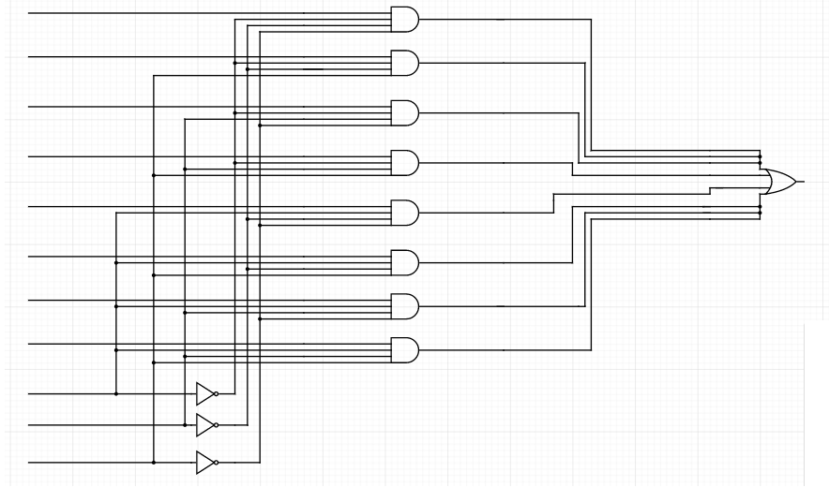 I0 O0

I1 O1

I2 O2

I3 O3

I4 O4

I5 O5

I6 O6

I7 O7

S0

S1

S2